**ENTERING ACCOUNTS PAYABLE INVOICES WITH MULTIPLE USERS**

1. Set the following parameter under System Administration so that logical value is set to “yes”

Logical value = YES,

Only the user ID that is logged into the system will be allow to update or delete A/P invoices for that User ID only. This allows each accounts payable clerk to work on batches of invoices.

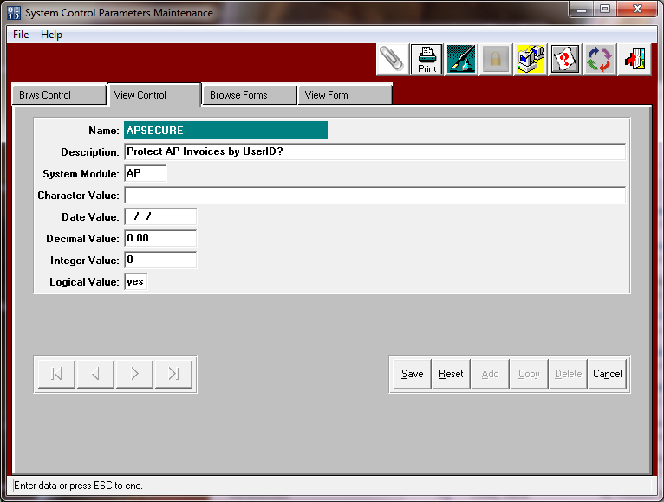

1. When entering AP invoices in VU1 you will notice that the user in the top right of screen will display the user id currently logged in.

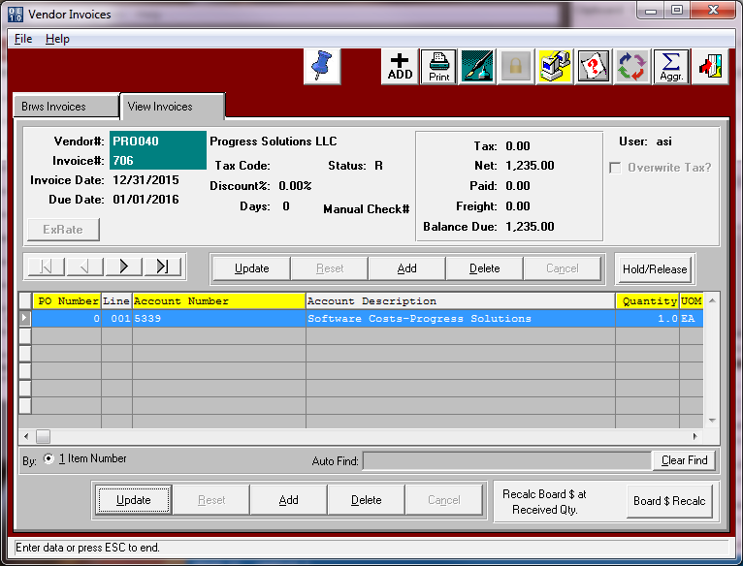

1. When posting invoices in VU2, make sure that you have YOUR user ID entered for the beginning and ending USER ID. This will allow you to only print and post the invoices you entered and not any other user.

